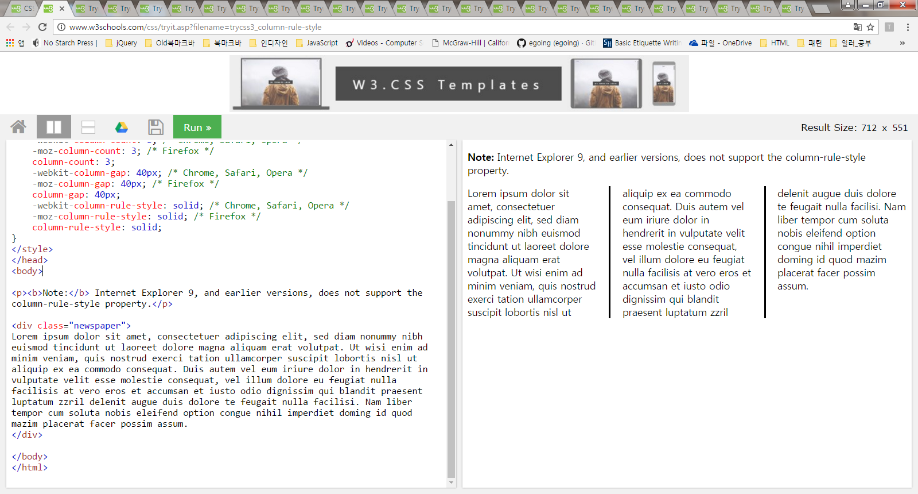

|  |
| --- |
| <!DOCTYPE html>  <html>  <head>  <style>  .newspaper {  -webkit-column-count: 3; /* Chrome, Safari, Opera */  -moz-column-count: 3; /* Firefox */  column-count: 3;  -webkit-column-gap: 40px; /* Chrome, Safari, Opera */  -moz-column-gap: 40px; /* Firefox */  column-gap: 40px;  -webkit-column-rule-style: solid; /* Chrome, Safari, Opera */  -moz-column-rule-style: solid; /* Firefox */  column-rule-style: solid;  }  </style>  </head>  <body>  <p><b>Note:</b> Internet Explorer 9, and earlier versions, does not support the column-rule-style property.</p>  <div class="newspaper">  Lorem ipsum dolor sit amet, consectetuer adipiscing elit, sed diam nonummy nibh euismod tincidunt ut laoreet dolore magna aliquam erat volutpat. Ut wisi enim ad minim veniam, quis nostrud exerci tation ullamcorper suscipit lobortis nisl ut aliquip ex ea commodo consequat. Duis autem vel eum iriure dolor in hendrerit in vulputate velit esse molestie consequat, vel illum dolore eu feugiat nulla facilisis at vero eros et accumsan et iusto odio dignissim qui blandit praesent luptatum zzril delenit augue duis dolore te feugait nulla facilisi. Nam liber tempor cum soluta nobis eleifend option congue nihil imperdiet doming id quod mazim placerat facer possim assum.  </div>  </body>  </html> |

Css 수정

<style>

.newspaper {

-webkit-column-count: 3; /* Chrome, Safari, Opera */

-moz-column-count: 3; /* Firefox */

column-count: 3;

-webkit-column-gap: 40px; /* Chrome, Safari, Opera */

-moz-column-gap: 40px; /* Firefox */

column-gap: 40px;

-webkit-column-rule: 1px solid lightblue; /* Chrome, Safari, Opera */

-moz-column-rule: 1px solid lightblue; /* Firefox */

column-rule: 1px solid lightblue;

}

</style>

<style>

.newspaper {

-webkit-column-count: 3; /* Chrome, Safari, Opera */

-moz-column-count: 3; /* Firefox */

column-count: 3;

-webkit-column-width: 100px; /* Chrome, Safari, Opera */

-moz-column-width: 100px; /* Firefox */

column-width: 100px;

}

</style>

CSS3 Resizing

|  |
| --- |
| <!DOCTYPE html>  <html>  <head>  <style>  div {  border: 2px solid;  padding: 20px;  width: 300px;  resize: vertical;  overflow: auto;  }  </style>  </head>  <body>  <p><b>Note:</b> Internet Explorer does not support the resize property.</p>  <div>Let the user resize the height of this div element.</div>  </body>  </html> |

|  |
| --- |
| <!DOCTYPE html>  <html>  <head>  <style>  div {  border: 2px solid;  padding: 20px;  width: 300px;  resize: vertical;  overflow: auto;  }  </style>  </head>  <body>  <p><b>Note:</b> Internet Explorer does not support the resize property.</p>  <div>Let the user resize the height of this div element.</div>  </body>  </html> |

|  |
| --- |
| <!DOCTYPE html>  <html>  <head>  <style>  div {  border: 2px solid;  padding: 20px;  width: 300px;  resize: both;  overflow: auto;  }  </style>  </head>  <body>  <p><b>Note:</b> Internet Explorer does not support the resize property.</p>  <div>Let the user resize both the height and the width of this div element.</div>  </body>  </html> |

## Media Query Syntax

@media not|only *mediatype*and(*expressions*) { *CSS-Code;*}

|  |
| --- |
| <link rel="stylesheet" media="mediatype and|not|only (expressions)" href="print.css"> |

|  |
| --- |
| <!DOCTYPE html>  <html>  <head>  <style>  body {  background-color: pink;  }  @media screen and (min-width: 480px) {  body {  background-color: lightgreen;  }  }  </style>  </head>  <body>  <h1>Resize the browser window to see the effect!</h1>  <p>The media query will only apply if the media type is screen and the viewport is 480px wide or wider.</p>  </body>  </html> |

|  |
| --- |
| <!DOCTYPE html>  <html>  <head>  <meta name="viewport" content="width=device-width, initial-scale=1.0">  <style>  .wrapper {overflow: auto;}  #main {margin-left: 4px;}  #leftsidebar {  float: none;  width: auto;  }  #menulist {  margin: 0;  padding: 0;  }  .menuitem {  background: #CDF0F6;  border: 1px solid #d4d4d4;  border-radius: 4px;  list-style-type: none;  margin: 4px;  padding: 2px;  }  @media screen and (min-width: 480px) {  #leftsidebar {width: 200px; float: left;}  #main {margin-left: 216px;}  }  </style>  </head>  <body>  <div class="wrapper">  <div id="leftsidebar">  <ul id="menulist">  <li class="menuitem">Menu-item 1</li>  <li class="menuitem">Menu-item 2</li>  <li class="menuitem">Menu-item 3</li>  <li class="menuitem">Menu-item 4</li>  <li class="menuitem">Menu-item 5</li>  </ul>  </div>  <div id="main">  <h1>Resize the browser window to see the effect!</h1>  <p>This example shows a menu that will float to the left of the page if the viewport is 480 pixels wide or wider. If the viewport is less than 480 pixels, the menu will be on top of the content.</p>  </div>  </div>  </body>  </html> |